“ML-Driven Early Detection for Optimal Health – Empowering You with Accurate Predictive Health Analytics”

# SUMMER INTERNSHIP SOPHOMORES PROJECT SPJ 2001­­­­­­

**AP20232410000130**

## Summer Id: 20240007

**First Review**

# UNDER THE GUIDANCE OF

Prof. Anil Vitthalrao Turukmane

**DEPARTMENT OF SCOPE (Speci. Networking And Security)**

# SUBMITTED BY

Madhu Alapaka - 21MIS7022.

Kothamasu Kaarthikeya - 21MIS7039.

Pulluru Nikhilesh - 21MIS7087.

**DEPARTMENT OF SCOPE(Integ M.TechSpec.in Software Engineering)**



**UNIFIED MODELING LANGUAGE DIAGRAMS (“U.M.L”)**

### **Unified Modeling Language (UML) Diagrams Overview**

* **Purpose**: UML provides a standardized notation to express software analysis and design models, governed by syntactic, semantic, and pragmatic rules. It enables software engineers to visualize, specify, construct, and document the artifacts of a software system.

### **Key Components of UML**

#### 1. **User Model View**

* **Purpose**: Represents the system from the users' perspective.
* **Diagrams**:
  + **Use Case Diagram**: Illustrates the interactions between users (actors) and the system, highlighting the functionalities (use cases) the system must support.
  + **Actors**: External entities such as users or other systems that interact with the system.
  + **Use Cases**: Specific functionalities or services provided by the system.

#### 2. **Structural Model View**

* **Purpose**: Depicts the static structure of the system, including its data and functional components.
* **Diagrams**:
  + **Class Diagram**: Shows the system's classes, attributes, operations, and the relationships between objects. It is essential for modeling the static design view of the system.
  + **Object Diagram**: Provides a snapshot of the system at a particular point in time, showing instances of classes and their relationships.

#### 3. **Behavioral Model View**

* **Purpose**: Represents the dynamic behavior of the system, showing how it interacts over time.
* **Diagrams**:
  + **Sequence Diagram**: Illustrates how objects interact in a particular sequence, focusing on the order of messages exchanged.
  + **Activity Diagram**: Captures the workflow of activities and actions within the system, similar to a flowchart.
  + **State Diagram**: Describes the states an object goes through during its lifecycle and the transitions between these states.

#### 4. **Implementation Model View**

* **Purpose**: Details how the system's structural and behavioral elements are to be realized in code.
* **Diagrams**:
  + **Component Diagram**: Depicts the organization and dependencies among software components, such as libraries, packages, and files.
  + **Deployment Diagram**: Shows the physical deployment of artifacts (software components) on nodes (hardware), including the relationships between hardware and software.

#### **5. Environmental Model View**

* **Purpose**: Illustrates the external environment where the system will operate, including physical and operational contexts.
* **Diagrams**:
  + **Deployment Diagram**: Also used here to show the runtime configuration in a specific environment.

### **DOMAINS OF UML:**

1. **UML Analysis Modeling**
   * Focuses on understanding and defining what the system must do from a user's perspective and its static structure.
   * Primarily uses the User Model and Structural Model views to capture requirements and define the static architecture of the system.
2. **UML Design Modeling**
   * Focuses on how the system will be built and how it will behave dynamically.
   * Uses Behavioral Model, Implementation Model, and Environmental Model views to define the dynamic aspects, implementation details, and environmental interactions.

### **Benefits of Using UML:**

* **Standardization**: Provides a common language for stakeholders, developers, and analysts to communicate.
* **Visualization**: Helps in visualizing the design of the system before implementation, making it easier to understand complex systems.
* **Documentation**: Offers a comprehensive documentation tool that can be referred to throughout the development lifecycle.
* **Analysis and Design**: Facilitates thorough analysis and design of the system, ensuring that all aspects are considered and properly addressed.

**“U.M.L” DIAGRAMS :**

* **USE CASE DIAGRAM :**
* Use case diagrams are visual representations of use cases. They show the actors, the system, and the use cases themselves, along with the relationships between them. These diagrams provide a high-level overview of the system's functionalities from the user's perspective.

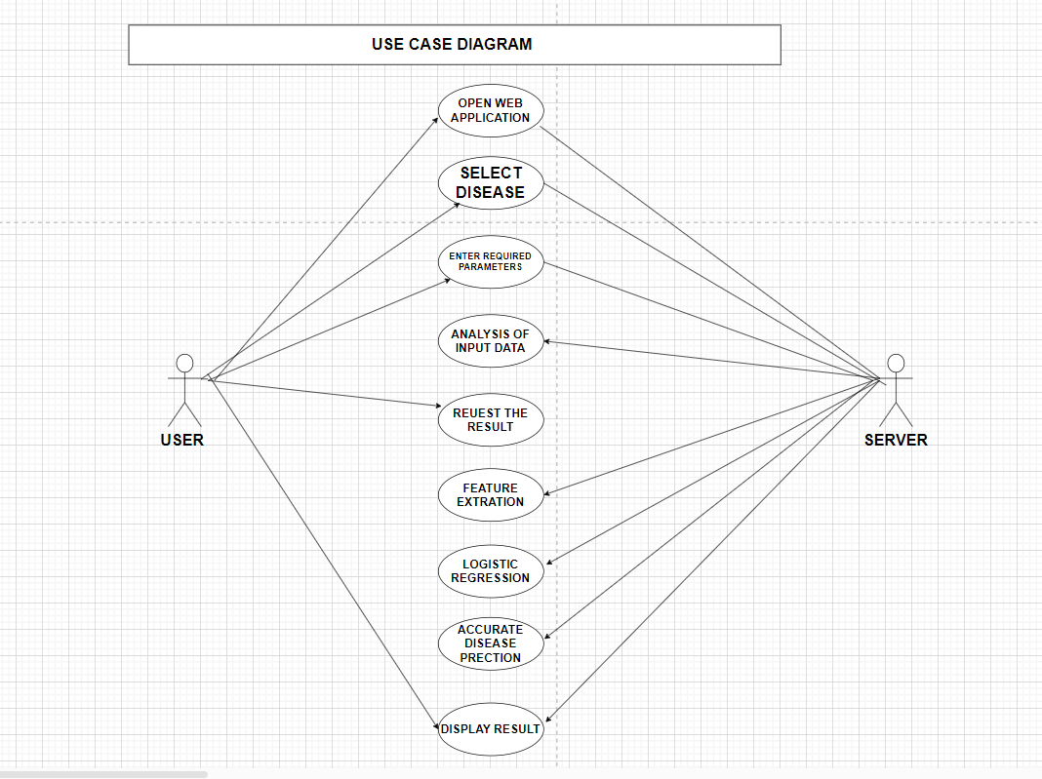

* use case diagram depicting the interactions between a user and a web application for disease identification through an open web application. Here's a breakdown of the components and their relationships:

**Components:**

* **Actor:** Represented by a stick figure labeled "User," this signifies the person interacting with the system.
* **System:** A rectangle labeled "Open Web Application" represents the software system, the web application for disease identification.
* **Use Cases:** Ellipses depict the functionalities provided by the system. Here, there are three use cases:
  + "Select Disease" allows the user to choose a specific disease from the application.
  + "Enter Required Parameters" signifies the user inputting relevant information needed by the system to identify the disease. This might include symptoms, medical history, or other details.
  + "Request Result" represents the user's action to initiate the analysis and receive results.

**Relationships:**

* Solid lines connect the user to each use case, indicating that the user can perform these actions or functionalities within the web application.
* **Overall Explanation:**
* This use case diagram provides a high-level overview of the web application's functionalities from the user's perspective. It shows that users can select a disease, enter required parameters, and request results, presumably to get the application to identify the disease based on the information provided.

**Key Points:**

* The use case diagram doesn't show the internal workings of the web application or how it identifies diseases.
* It focuses on user interactions and the functionalities available through the web application.
* **CLASS DIAGRAM :**
* A class diagram, in the context of software engineering, is a visual representation of the classes in a system and the relationships between them. It's a core concept in object-oriented design (OOD) and is used for various purposes throughout the software development lifecycle.

Here's a breakdown of the key aspects of class diagrams:

* **Main Components:**
* **Classes:** These are blueprints that define the properties (attributes) and functionalities (methods) of objects. In the class diagram, classes are typically depicted as rectangles with compartments for the class name, attributes, and methods.
* **Attributes:** These represent the characteristics or data points associated with an object of a particular class. They are listed within the first compartment of the class rectangle.
* **Methods:** These represent the actions or functionalities that objects of a class can perform. They are listed within a separate compartment of the class rectangle, often below the attributes.
* **Relationships:** Relationships between classes are depicted using lines or arrows connecting them. These relationships can represent different types of interactions, such as inheritance (where one class inherits properties and methods from another), association (where objects of two classes have a connection), or aggregation (where one class is a part of another).
* **Key components:**

• **User**: Interacts with the web application to get disease predictions.

• **DiseasePredictionApp**: The main application that coordinates the interaction between the user, disease list, and prediction logic.

• **Disease**: Represents a disease that the user can select.

• **PredictionModel**: Contains the machine learning logic to make predictions based on user input.

• **UserInput**: Collects and stores the input values from the user.

• **PredictionResult**: Stores the result of the prediction.

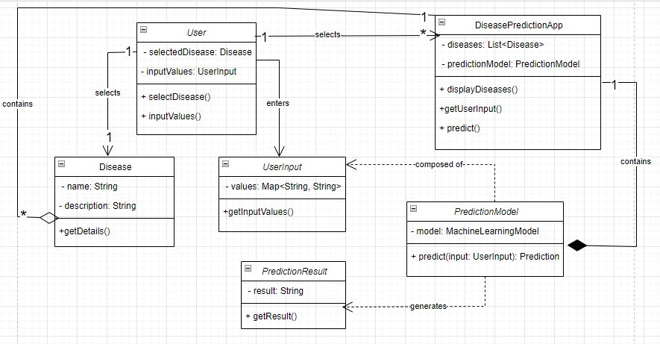

### **Explanation:**

1. **User**:
   * Attributes:
     + selectedDisease: The disease selected by the user.
     + inputValues: The values input by the user.
   * Methods:
     + selectDisease(): Allows the user to select a disease.
     + inputValues(): Allows the user to input values.
2. **DiseasePredictionApp**:
   * Attributes:
     + diseases: A list of available diseases.
     + predictionModel: The machine learning model used for predictions.
   * Methods:
     + displayDiseases(): Displays the list of diseases for the user to select.
     + getUserInput(): Gets the input values from the user.
     + predict(): Makes a prediction based on the user's input and selected disease.
3. **Disease**:
   * Attributes:
     + name: The name of the disease.
     + description: A description of the disease.
   * Methods:
     + getDetails(): Returns the details of the disease.
4. **PredictionModel**:
   * Attributes:
     + model: The machine learning model used for prediction.
   * Methods:
     + predict(input: UserInput): PredictionResult: Makes a prediction based on the user's input and returns the result.
5. **UserInput**:
   * Attributes:
     + values: A map of input field names to input values.
   * Methods:
     + getInputValues(): Returns the user's input values.
6. **PredictionResult**:
   * Attributes:
     + result: The prediction result.
   * Methods:
     + getResult(): Returns the prediction result.

### **Relationships Explained:**

1. **User to DiseasePredictionApp**: The user interacts with the DiseasePredictionApp to perform actions like selecting a disease and inputting values (Association).
2. **DiseasePredictionApp to Disease**: The DiseasePredictionApp contains a list of Disease objects, indicating aggregation.
3. **DiseasePredictionApp to PredictionModel**: The DiseasePredictionApp includes a PredictionModel, implying a composition relationship.
4. **User to Disease**: The user selects a disease from the available options provided by the DiseasePredictionApp (Association).
5. **User to UserInput**: The user provides input values that are stored in a UserInput object (Association).
6. **PredictionModel to UserInput**: The PredictionModel depends on the UserInput to make predictions (Dependency).
7. **PredictionModel to PredictionResult**: The PredictionModel produces a PredictionResult based on the UserInput (Dependency).

* **STATE DIAGRAM :**
* A state chart diagram represents the different states of an object and how it transitions from one state to another based on events. Here is a state chart diagram for the web application described

### 

### **Explanation:**

1. **START: the process starts being**
2. **Initial State**: The starting point of the state chart.
3. **Waiting for the User to Start**: The application is waiting for the user to initiate the process.
4. **Display Diseases**: The state where the application displays the list of diseases.
5. **Disease Selected**: The state entered after the user selects a disease.
6. **Prompt for User Input**: The application prompts the user to enter the required input values for the selected disease.
7. **Collecting Input**: The state where the application is collecting input values from the user.
8. **Predicting Disease**: The application uses the input values to make a prediction using the machine learning model.
9. **Displaying Result**: The state where the application displays the prediction result to the user.
10. **Final State**: The endpoint of the state chart, indicates that the process is complete.
11. **END**: THE PROCESS ENDING STATE

* This state chart diagram provides a clear view of the different states the application goes through, from the initial state to the final state, based on user interactions and events within the system.
* **ACTIVITY DIAGRAM :**

### **Explanation:**

### An activity diagram provides a visual representation of the workflow or process.OR is a graphical representation that depicts the flow of activities and actions within a system. It focuses on the sequential or concurrent steps involved in a process, highlighting decision points, alternative paths, and synchronization points between different parts of the system.

1. **Start**: The activity begins.
2. **Display Diseases**: The application displays the list of diseases available for selection.
3. **Select Disease**: The user selects a disease from the displayed list.
4. **Prompt for User Input**: The application prompts the user to enter the required input values for the selected disease.
5. **User Enters Values**: The user inputs the required values.
6. **Collect Input Values**: The application collects the input values entered by the user.
7. **Make Prediction**: The application uses the collected input values and the selected disease to make a prediction using the machine learning model.
8. **Display Prediction Result**: The application displays the prediction result to the user.
9. **End**: The activity ends.

* This activity diagram provides a clear view of the steps involved in the process, from the user selecting a disease to receiving a prediction result.

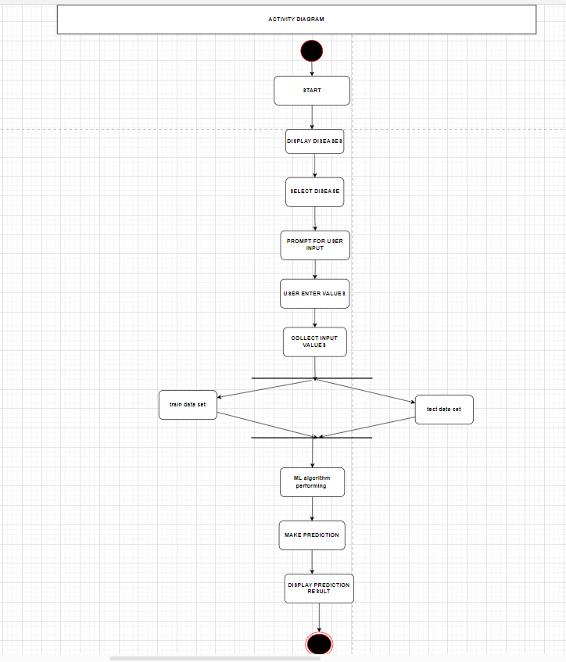

* **SEQUENCE DIAGRAM:**
* Overall, sequence diagrams are a valuable tool for visualizing and documenting the interactions between objects in a system, especially when focusing on the message flow in a specific scenario

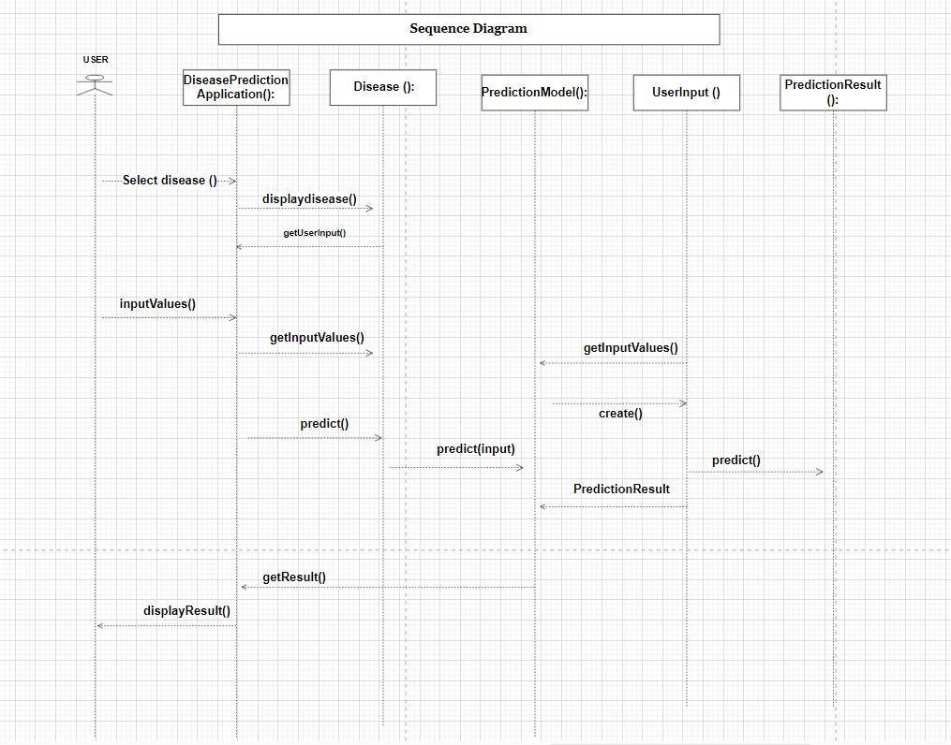

* **Explanation:**
* This sequence diagram outlines the flow of actions from user interaction to prediction result generation and sequence diagram is a type of interaction diagram that focuses on the message flow between objects in a specific scenario or use case. It depicts the interactions chronologically, highlighting the sequence of messages exchanged between objects as they collaborate to achieve a particular goal.

1. **User selects a disease**:
   * The User selects a disease via the selectDisease() method.
   * DiseasePredictionApp calls displayDiseases() to show the list of diseases.
   * The User then sees the list and selects a disease.
2. **User input values**:
   * The User provides input values via the inputValues() method.
   * DiseasePredictionApp calls getInputValues() to retrieve the user inputs.
3. **PredictionModel processes the input**:
   * DiseasePredictionApp creates a UserInput object with the collected values.
   * DiseasePredictionApp calls predict() on the PredictionModel, passing the UserInput.
   * The PredictionModel processes the input and generates a PredictionResult.
4. **A user receives the prediction result**:
   * DiseasePredictionApp retrieves the result using getResult().
   * The result is displayed to the User via the displayResult() method.

* **COLLABORATION DIAGRAM :**
* A collaboration diagram, also known as a communication diagram, focuses on the interactions between objects and their relationships. It is based on the sequence diagram provided earlier.

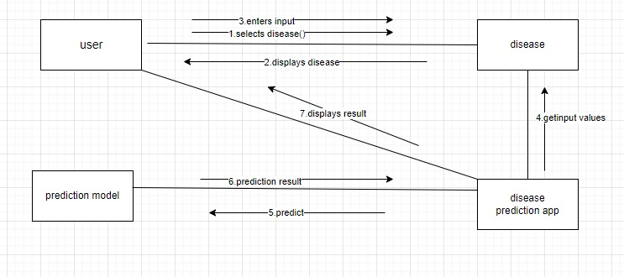

### **Explanation:**

1. **User selects a disease**:
   * The User initiates the interaction by calling selectDisease() on the DiseasePredictionApp.
2. **DiseasePredictionApp displays diseases**:
   * The DiseasePredictionApp responds by calling displayDiseases() to show the list of available diseases.
3. **User input values**:
   * The User provides input values by calling inputValues() on the DiseasePredictionApp.
4. **DiseasePredictionApp collects input values**:
   * The DiseasePredictionApp collects the input values by calling getInputValues() on itself.
5. **DiseasePredictionApp makes a prediction**:
   * The DiseasePredictionApp calls predict() on the PredictionModel to make a prediction based on the user inputs.
6. **PredictionModel processes the input**:
   * The PredictionModel calls predict(input) using the UserInput to generate a PredictionResult.
7. **PredictionResult generated**:
   * The PredictionModel returns a PredictionResult.
8. **DiseasePredictionApp retrieves the result**:
   * The DiseasePredictionApp retrieves the prediction result by calling getResult() on the PredictionModel.
9. **Displaying the result to the user**:
   * Finally, the DiseasePredictionApp displays the prediction result to the User by calling displayResult().

* This collaboration diagram showcases how objects interact to fulfill the use case of predicting a disease based on user input.
* **COMPONENT DIAGRAM:**
* Absolutely! Here's a breakdown of the UML component diagram based on the title "ML-Driven Early Detection for Optimal Health – Empowering You with Accurate Predictive Health Analytics":

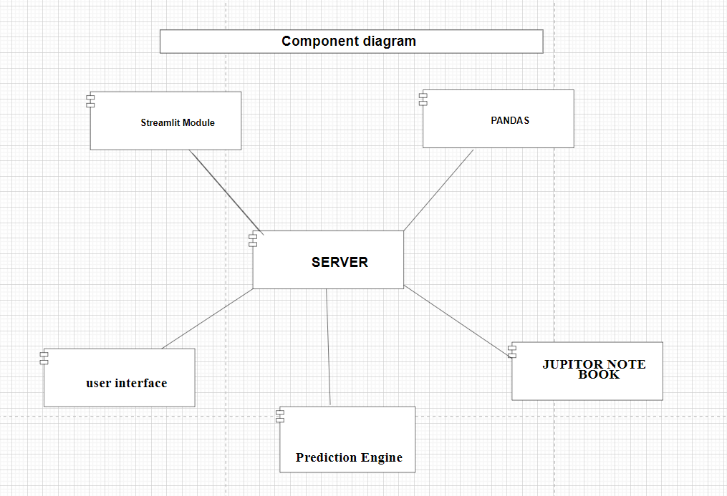

* **Key Components:**
* **User Input (data):** This represents the data a user provides to the system. In the context of healthcare, this could be information about symptoms, health history, or other relevant details.
* **Streamlit Module:** This likely signifies a software library used to create the user interface (UI) of the system. Streamlit allows for building data apps quickly, suggesting an interactive interface for users to input data and potentially view results.
* **Server:** This is the central component of the system, responsible for processing user data and generating predictions. It acts as a bridge between the user interface and the prediction engine.
* **Pandas:** This is likely a Python library used for data analysis and manipulation on the server side. Pandas help manage and clean the user data before feeding it into the prediction engine.
* **Jupyter Notebook:** This component signifies a software environment where data scientists or developers might have created the machine learning model used for predictions. It wouldn't be a direct part of the deployed system but signifies the origin of the prediction logic.
* **Relationships:**
* **User Input (data) connects to Server:** This arrow depicts the flow of user data from the input interface to the server for processing.
* **Streamlit Module connects to Server (user interface):** This connection signifies that the Streamlit module provides the user interface that interacts with the server. It allows users to input data and potentially receive results generated by the server.
* **Jupyter Notebook connects to Server (Prediction Engine):** This doesn't represent a direct connection in the deployed system but indicates that the prediction engine logic likely originated from a Jupyter Notebook where it was developed and trained. The server would use this pre-trained model for making predictions.
* **Pandas Connect to Server:** This implies that the Pandas library is used on the server side, likely for data manipulation and preparation before feeding it into the prediction engine.
* **Overall Explanation:**

This UML component diagram depicts a system designed for Machine Learning-based health predictions. Users interact with a UI likely built using Streamlit, providing their health data. The server receives this data, potentially cleans and prepares it using Pandas, and then utilizes a pre-trained prediction engine (developed in Jupyter Notebook) to generate predictions.

* **DEPLOYMENT DIAGRAM:**
* A deployment diagram in UML shows the physical deployment of artifacts on nodes, such as how software components (artifacts) are deployed on hardware components (nodes). Here's a deployment diagram for the Disease Prediction System:

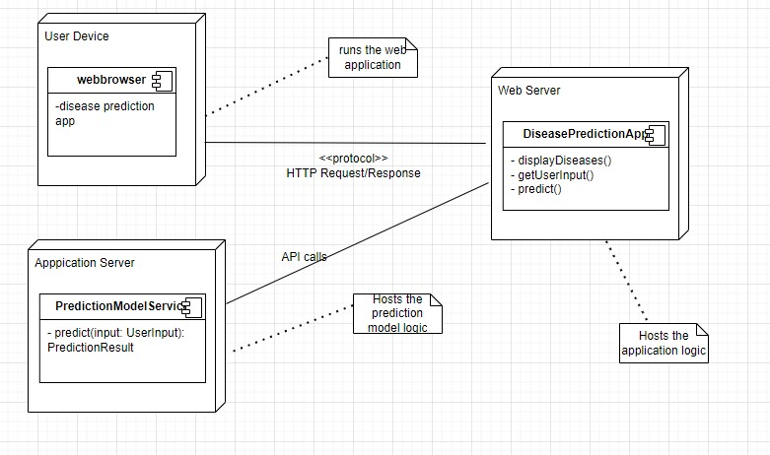

### **Explanation of the Deployment Diagram:**

1. **User Device**:
   * Represents the device used by the user to interact with the web application.
   * Contains a Web Browser running the DiseasePredictionApp.
2. **Web Server**:
   * Hosts the DiseasePredictionApp.
   * Handles HTTP requests and responses between the user device and the web server.
3. **Application Server**:
   * Hosts the PredictionModelService.
   * Handles API calls for predictions and processes user inputs using the prediction model.

### **Key Components:**

* **Web Browser**:
  + Executes the front-end part of the DiseasePredictionApp and communicates with the Web Server.
* **DiseasePredictionApp**:
  + Handles displaying diseases, collecting user input, and making predictions.
  + Deployed on the Web Server.
* **PredictionModelService**:
  + Contains the prediction logic using the machine learning model.
  + Deployed on the Application Server.

### **Communication:**

* **HTTP Request/Response**:
  + Between the User Device and the Web Server.
  + For interactions like selecting diseases and submitting input values.
* **API Calls**:
  + Between the Web Server and the Application Server.
  + For invoking prediction logic.

**ER – Diagram / Model Design :**

* The relation upon the system is structured through a conceptual ER-Diagram, which not only specifics the existential entities but also the standard relations through which the system exists and the cardinalities that are necessary for the system state to continue.

• The entity Relationship Diagram (ERD) depicts the relationship between the data objects. The ERD is the notation that is used to conduct the data modeling activity the attributes of each data object noted in the ERD can be described resign a data object description.

• The set of primary components that are identified by the ERD are

• Data object

• Relationships

• Attributes

• Various types of indicators.

The primary purpose of the ERD is to represent data objects and their relationships.

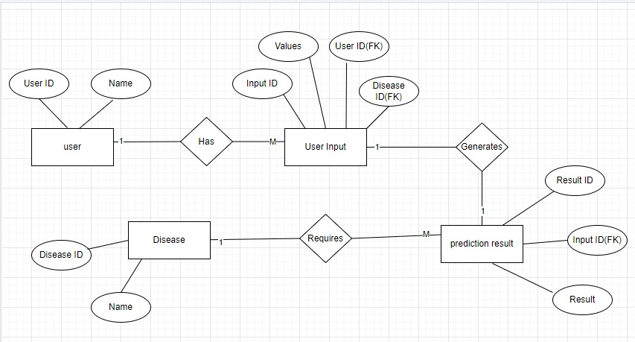

### **Explanation:**

1. **User**:
   * Attributes:
     + UserID: Unique identifier for the user.
     + Name: The name of the user.
2. **Disease**:
   * Attributes:
     + DiseaseID: Unique identifier for the disease.
     + Name: The name of the disease.
     + Description: A description of the disease.
3. **UserInput**:
   * Attributes:
     + InputID: Unique identifier for the user input.
     + Values: The input values provided by the user.
     + UserID (FK): Foreign key referencing the User.
     + DiseaseID (FK): Foreign key referencing the Disease.
4. **PredictionResult**:
   * Attributes:
     + ResultID: Unique identifier for the prediction result.
     + Result: The result of the prediction.
     + InputID (FK): Foreign key referencing the UserInput.

### **Relationships:**

1. **User to UserInput**:
   * A User can have many UserInput entries, but each UserInput is associated with only one User (One-to-Many relationship).
2. **UserInput to Disease**:
   * A UserInput is associated with one Disease (Many-to-One relationship).
3. **UserInput to PredictionResult**:
   * Each UserInput generates one PredictionResult (One-to-One relationship).
4. **PredictionResult requires Disease**:
   * A PredictionResult requires a Disease to provide context for the prediction (Many-to-One relationship).

This ER diagram helps visualize the data structure and relationships in your web application.

**DATA.FLOW.DIAGRAM -DFD :**

* This DFD provides a high-level overview of the disease prediction system. It shows that the system interacts with a user, retrieves information about a disease, leverages a disease prediction model, and displays the predicted disease back to the user. It doesn't delve into the specifics of how the prediction model works but focuses on the data flow between the user and the system.
* Data Flow Diagrams (DFDs) are graphical representations used to depict the flow of data within a system. They break down the system into processes and show how data moves between them. Here's a breakdown of the different levels of DFDs:
* **DATA FLOW DIAGRAM – DFD ( 0th level) :**
* **Level 0: Context Diagram**
* **Focus:** Provides a high-level overview of the entire system.
* **Components:**
  + **Single Process:** Represents the entire system as a single bubble.
  + **External Entities:** Actors or systems outside the system that interact with it (e.g., users, databases).
  + **Data Flows:** Arrows depicting the flow of data between external entities and the system process.
* **Purpose:** Provides a starting point for system analysis, defining the overall scope and interactions with the external world.

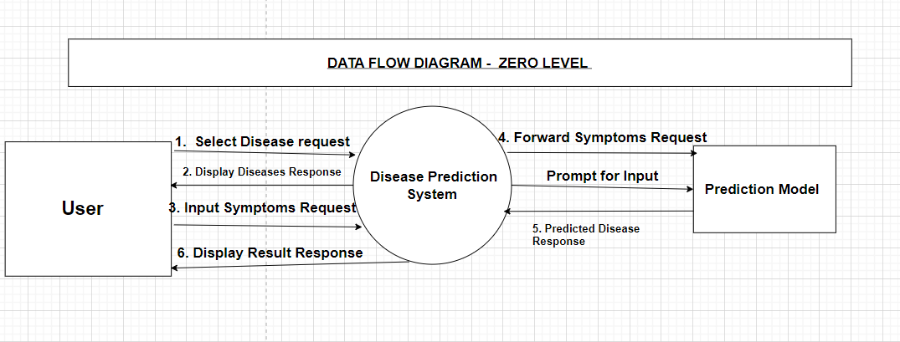

* **Key components:**

**1. User:**

* This represents the individual who interacts with the system. They might input information about their health condition, symptoms, or any relevant details regarding a potential disease. This information could be entered through a user interface (UI) that is not explicitly shown in the description.

**2. Disease Prediction System:**

* This is the core system responsible for processing user data and generating disease predictions. It acts as an intermediary between the user and the prediction model. Here's what the system might do:
  + **Receive User Input:** The system gathers the information provided by the user.
  + **Process and Prepare Data:** The system might clean, format, or transform the user data into a format suitable for the prediction model.
  + **Interact with Prediction Model:** The system sends the processed user data to the prediction model.
  + **Receive Prediction Results:** The system retrieves the predicted disease information from the model.
  + **Display Results:** The system displays the predicted disease information for the user, likely through a user interface.

**3. Prediction Model:**

* This component represents the external resource used for generating disease predictions. It could be a pre-trained machine learning model, a database of medical knowledge, or any other external system capable of analyzing the user's data and providing disease predictions.
* The prediction model likely receives the processed user data from the disease prediction system and analyzes it based on its internal mechanisms. It then generates a prediction or response, which is sent back to the disease prediction system.
* **Overall Interaction:**

1. The user interacts with the system by providing information about their health condition.
2. The disease prediction system receives this information and processes it.
3. The system sends the processed data to the prediction model.
4. The prediction model analyzes the data and generates a predicted disease.
5. The prediction model sends the prediction result back to the disease prediction system.
6. The disease prediction system displays the predicted disease information for the user.

* **DATA FLOW DIAGRAM – DFD ( 1st level) :**
* **Level 1: Detailed Context Diagram**
* **Focus:** Expands on the context diagram by decomposing the single system process into its primary sub-processes.
* **Components:**
  + **Multiple Processes:** This breaks down the central process from level 0 into more specific sub-processes that perform distinct functionalities.
  + **Data Stores:** Represents temporary or permanent repositories where data is stored within the system.
  + **Data Flows:** Arrows depicting the flow of data between processes, external entities, and data stores.
* **Purpose:** Provides a more detailed view of the system's internal workings, highlighting the main functionalities and data flow between them.

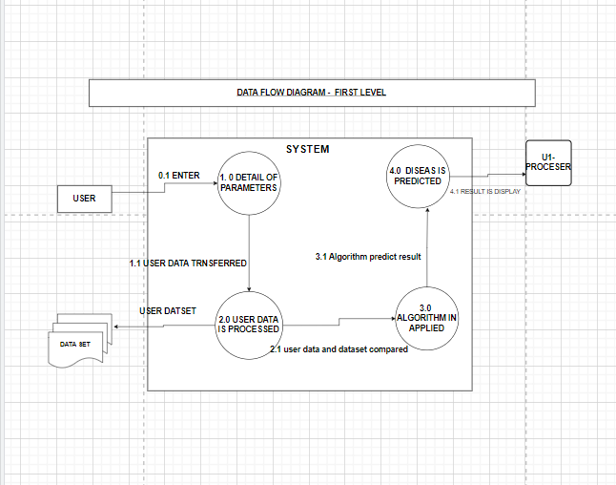

* **Main Aspects:**
* **User:** This represents the individual who interacts with the system, providing their health information and receiving disease predictions.
* **Dataset (Disease Prediction Model):** This signifies the external resource used for generating disease predictions. It could be a pre-trained machine learning model, a database of medical knowledge, or any system capable of analyzing user data and predicting potential diseases.
* **User Interface (Implicit):** While not explicitly shown in the DFD, a user interface (UI) is likely present. This is the software element that the user interacts with to provide input and receive disease prediction results.
* **Key Components:**
* **Process (Disease Prediction System):** This central rectangle represents the core system that manages the entire disease prediction process. It interacts with the user, the dataset (disease prediction model), and the UI (implicit).
* **Data Flows (4):**
  + **Select Disease Request (implicit):** This flow likely originates from the User through the UI and points to the Disease Prediction System. It signifies the user initiating the process, possibly by selecting a disease of interest or requesting a general health evaluation.
  + **Forward Symptoms Request:** This flow originates from the Disease Prediction System and points to the Dataset (disease prediction model). It depicts the system sending the user's information or symptoms to the model for analysis.
  + **Predicted Disease Response:** This flow originates from the Dataset and points back to the Disease Prediction System. It represents the predictions or analysis results sent back by the model.
  + **Display Real-Time Response:** This flow originates from the Disease Prediction System and points to the implicit User Interface. It signifies the system displaying the disease predictions or health analysis results for the user.
* **DATA FLOW DIAGRAM – DFD ( 2nd level) :**
* **Level 2: Exploded View**
* **Focus:** Dives deeper into a specific sub-process from level 1, illustrating its internal details.
* **Components:**
  + **Sub-process Breakdown:** Expands on a particular sub-process from level 1, further decomposing it into even more granular sub-processes or steps.
  + **Data Stores (Optional):** This may include additional data stores relevant to the specific sub-process being analyzed.
  + **Data Flows:** Arrows depicting the flow of data between the sub-processes within the exploded process and any relevant data stores.
* **Purpose:** Provides a very detailed view of a specific sub-process, allowing for a detailed step-by-step process.

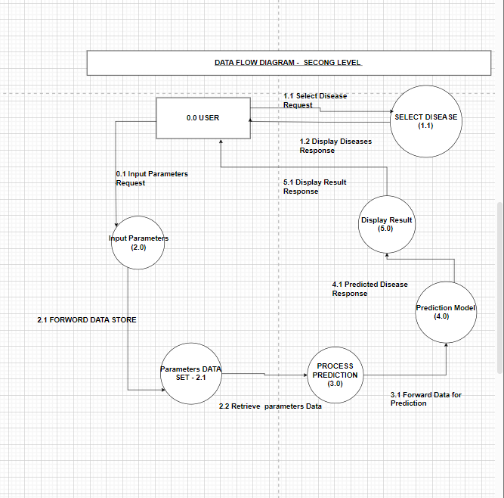

the key components and their relationships in the level 2 DFD appear to be as follows:

* **Key Components:**
* **User:** This represents the external entity that interacts with the system, likely a patient providing their symptoms or medical information.
* **Select Disease:** This could be interpreted in two ways:
  + **Process:** It might represent a user action within the system, where they select a specific disease of interest from a menu or list.
  + **Data Flow:** Alternatively, it could depict the user's input specifying the disease they are interested in learning more about.
* **Input Parameters:** This signifies the data provided by the user, likely their symptoms or medical history details.
* **Parameters Data:** This could be a data store that holds the user-provided input parameters (symptoms/medical history).
* **Process Prediction:** This represents the central process responsible for analyzing the user's input data to predict a potential disease. It likely leverages the Prediction Model (data store) for this analysis.
* **Prediction Model:** This signifies a data store or external resource that contains the knowledge or model used for disease prediction. It could be a pre-trained machine learning model or a database of medical knowledge.
* **Display Result:** This could be interpreted in two ways:
  + **Process:** It might represent the system's action of displaying the predicted disease(s) for the user.
  + **Data Flow:** Alternatively, it could depict the output data from the system, which is the predicted disease information.
* **Key Relations:**
* Data flow diagrams (DFDs) typically use arrows to depict data flow, not numbers to represent relations. Here's an explanation of the data flows based on the interpretation of the components:

1. **The user initiates:** The process starts with the user initiating the interaction, possibly by selecting a disease of interest (if interpreted as a process) or providing their symptoms/medical history (if interpreted as data flow). This user input is represented by the arrow labeled "Select Disease" or "Input Parameters".
2. **Data flow to process:** The user-provided data (symptoms/medical history) flows into the "Process Prediction" block.
3. **Data flow to data store (optional):** The user input might be stored in the "Parameters Data" store for further processing or reference.
4. **Process Prediction interacts with model:** The "Process Prediction" block interacts with the "Prediction Model" (data store), likely using the user data to query the model and generate predictions.
5. **Prediction results to display:** The outcome of the prediction process, likely the disease predictions, flows to the "Display Result" block.
6. **The system displays results:** The "Display Result" block (interpreted as a process) presents the predicted disease information to the user.

**Overall, the level 2 DFD depicts the user providing medical information, the system analyzing it using a prediction model, and displaying the predicted disease(s) for the user.**

**Final Conclusion**

The comprehensive set of UML diagrams for the Multiple Disease Prediction System provides a detailed visualization of the system's design, interactions, and architecture. The use case diagram clarifies functional requirements and user interactions, while the class diagram outlines the system's structure. The state diagram illustrates component states and transitions, and the activity diagram maps out the workflow. The sequence diagram shows interaction flows for specific use cases, and the ER diagram depicts the database structure. The collaboration diagram highlights object interactions and relationships, while the component diagram presents the organization and dependencies among software components. Finally, the DFD diagrams (Levels 0, 1, and 2) illustrate the data flow within the system. Together, these diagrams ensure a well-structured, coherent, and effective implementation of the system.